DATA VISUALIZATION
FINAL PROJECT

Navaneeth Bitla,
Harshitha Dhanekula
MSDS670
Regis University
Introduction
Data visualization plays a critical role in understanding patterns and insights within large datasets. By transforming raw data into visual representations, analysts can identify trends, relationships, and anomalies that might otherwise remain hidden.
The goal of this project is to analyze order activity within a retail dataset using Python-based data visualizations. The analysis focuses on identifying patterns in order growth, understanding customer segments, and examining geographic distribution across regions and countries.
The central research question guiding this project is:
How do order trends, customer segments, and geographic regions influence overall order activity over time?
To answer this question, multiple visualizations were created using Python libraries such as Matplotlib, Seaborn, and Plotly.
Data
The data set used in this project contains transaction-level order data from a retail business. Each record includes information such as order date, customer segment, region, country, and shipping details.
Key variables used in the analysis include:
- Order Date – used to analyze trends over time
- Customer Segment – identifies Consumer, Corporate, and Home Office customers
- Region – geographic grouping of orders
- Country – individual countries contributing orders
Before performing visualization, the dataset was cleaned and transformed using Python. Date fields were converted to datetime format, and monthly aggregates were calculated to analyze order trends over time.

Visulalization-1
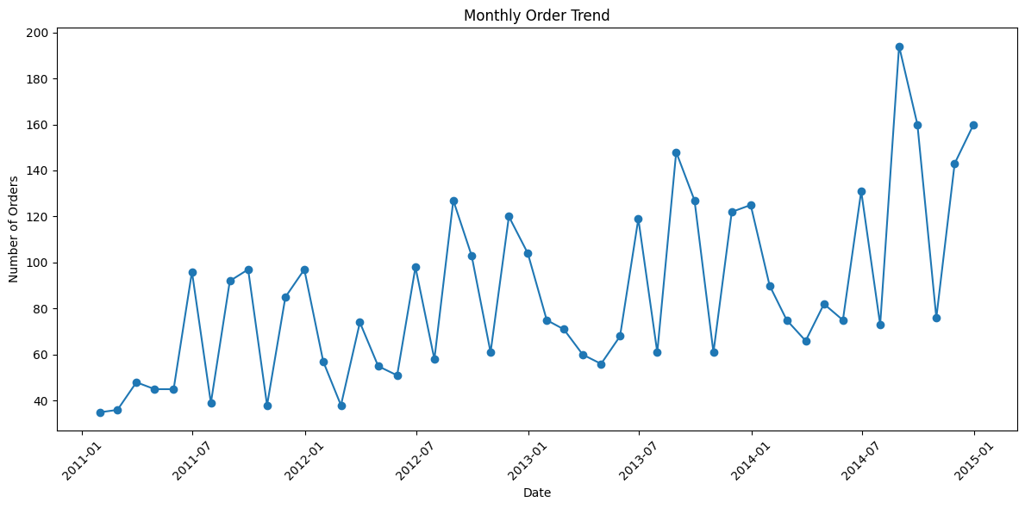
The first visualization examines the monthly order trend. The results show that order volume increases steadily over the four-year period from 2011 to 2014. Although there are fluctuations between individual months, the overall pattern demonstrates consistent growth in customer activity.
Visulalization-2
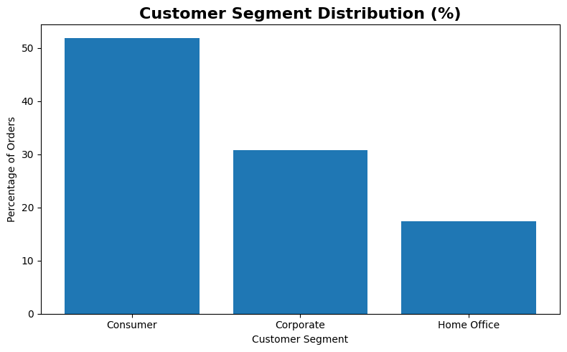
The second visualization shows the distribution of orders across customer segments. The results reveal that Consumer customers account for the majority of total orders. Corporate customers represent a smaller but still significant portion, while Home Office customers contribute the smallest share.
Visulalization-3
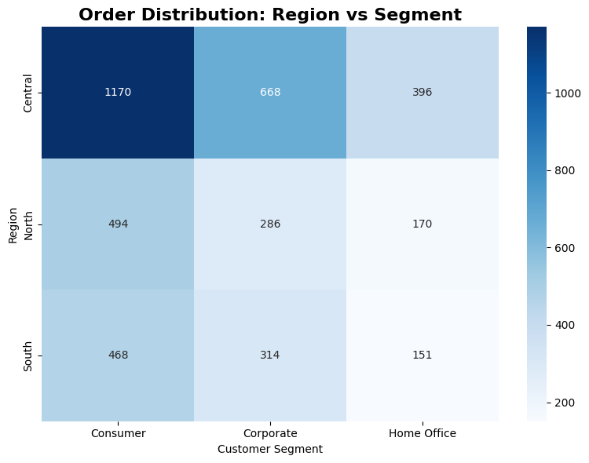
The third visualization uses a heatmap to compare order distribution by region and customer segment. The Central region has the highest number of orders overall, and Consumer customers dominate across all regions. This indicates that consumer demand plays the largest role in order activity.

Visulalization-4
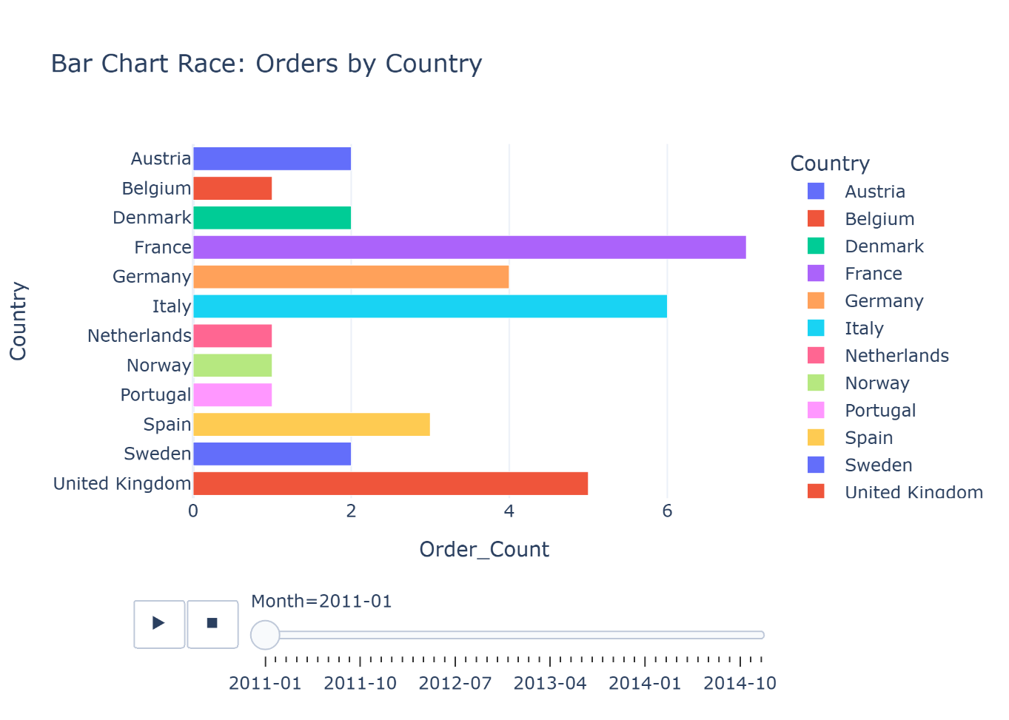
The final visualization is an animated bar chart race showing orders by country over time. This dynamic visualization highlights how order rankings change month by month. Several countries consistently generate strong demand, while others contribute smaller but stable order volumes.
Conclusions
The analysis reveals several important insights into the order dataset.
- First, order volume increased steadily between 2011 and 2014, suggesting expanding business activity and increasing customer demand.
- Second, Consumer customers represent the largest segment of the market, indicating that individual buyers drive most order activity.
- Third, geographic patterns reveal differences in order distribution across regions and countries, highlighting areas with stronger market presence.
Overall, the visualizations demonstrate how data visualization techniques can effectively reveal trends, patterns, and relationships within transactional data.

